My Healthcare Notebook
Purpose:
The purpose of this notebook is to provide a visual support to guide you through the steps of a medical appointment (check-in, during the visit, check-out). There can be a lot happening during a medical appointment—lots of steps to follow, things to remember, etc. Having a visual guide can help you cue you to remember certain steps which can in turn help reduce anxiety. Additionally, the inside of the notebook can be a great place to store a few of your communication strategies such as your About Me Form and your Appointment Prep Form.

Please note: this notebook provides a great starting point, but, if desired, please adapt it to meet your specific needs.

Directions:
- Find an empty 3-ring binder that you can use for your notebook.

- Print the 3 cards (Check-in, During the Visit & Check-out).

- Read the cards and ensure that they match your needs. For example, the Check-in Card has a list of coping strategies to use while in the waiting room and/or during your time with the provider. You may have different coping strategies that you prefer, so adapt the list to match your preferences.

- If desired, laminate the cards to make them more durable.

- Attach the cards to the front of the notebook, with the Check-in card on top, During the Visit card next and the Check-out card on the bottom. We used Velcro pieces to attach the cards, but you may use a clip, tape or any other method of attaching the cards. Before deciding on how you will attach the cards we recommend you read step #7a to learn how you can use and move the cards during a healthcare appointment.

- On the inside of the binder, insert copies of your completed About Me Form. Prior to an appointment you can also store your completed Appointment Prep Form so that all is together in one location.

- To use the notebook during a healthcare appointment,

  - OUTSIDE of notebook-follow the steps and reminders on each card to help you navigate each part of the appointment. Use the check-in card during the check-in process. Once you get called back with the provider, move the check-in card to the back of the binder (or tuck it inside of the binder) and now the During the Visit card should be visible. Do the same for the check-out process. Once you are done with the provider, move the During the Visit Card to the back/inside of the binder and now the Check-Out card will be showing for your reference.
  - INSIDE of notebook-if it is your first visit with a provider, give them a copy of your About Me form in the beginning of the visit. This will help them know what you need to be successful during your visit. Also provide a copy of your Appointment Prep Form in order to help communicate your symptoms/concerns. Finally, keep copies of the Appointment Summary Form in your notebook and complete it with assistance from your provider before leaving the appointment.
FIRST
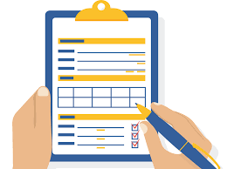
CHECK-IN

During check in I will:

Pay

Fill out paperwork
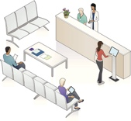

Wait in the waiting room until my name is called

In the waiting room, I can use or do the following to cope with sensory challenges/anxiety:

noise cancellation headphones | Tools in my sensory bag | Deep breathing  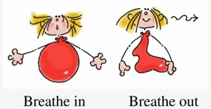
Pacing | Progressive muscle relaxing | Sensory mindfulness exercise
Work on emails using phone | Read | Ask to wait in hallway where it will be quieter  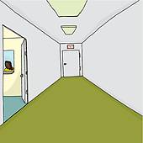

Remember:

If I have not been called after 30 minutes ask the receptionist how much longer I will need to wait.
Next

SEEING THE DOCTOR

FIRST
When I am called to see the doctor, a nurse will get my weight, temperature, and BP. The nurse will also go over medications and concerns.

NEXT
I will need to wait in the office room for the doctor to come in. During this time, I can use my coping strategies to help pass the time and to stay calm.

THEN
The doctor will come in to see me. If it is the first time I am seeing this doctor, give them my About Me Form. Also, when the doctor asks about symptoms/concerns, give my Appointment Prep Form to the doctor.

ANSWER THE FOLLOWING BEFORE THE DOCTOR LEAVES:

Did I get all of my questions answered?

Do I understand what I am supposed to do next?

Did the Doctor give me back my forms?

Remember:

I do not have to do anything I am uncomfortable with

I can use a communication app if I am struggling to speak

I can use my coping strategies to help me stay calm

Then

CHECKING OUT

Pay if I did not pay in the beginning

Make follow up appointment if needed

Make sure my Appointment Summary Form is filled out and I know the next steps

