Body Check Form

Purpose:
The feelings in your body can provide important clues to your health. The purpose of this exercise is to help you better notice and identify the feelings in your body. Once completed, the body outline on page 2 will visually show how your body feels. It can even serve as a communication tool that you bring to your medical appointments to help your provider better understand what your body is experiencing.

Directions:
Try completing a Body Check Form at least one time a day.

- Go to a location where you feel comfortable

- Focus your attention on your body

- For each body part pause and notice what sensations/feelings you are experiencing.

- Label what you notice on the body outline on page 2.

Helpful Hints:
- When doing this exercise feel free to sit, lay down, stand, pace, etc. when completing the Body Check Form. Do what makes you feel most comfortable.

- When trying to notice what sensations or feelings you are experiencing it may help to start at the top of your body (at your head) and work your way down to your feet.

- Try to identify and then label your sensations/feelings for one body part before moving to the next

- Sometimes you may not notice a feeling/sensation in a body part right away. When this happens try to spend at least 1 minute focusing on this part before moving on to the next. While focusing, pay attention to your thoughts; they may serve as a clue to what your body part is feeling like. If after a minute you still cannot identify your sensations/feelings, it is okay, just move on to the next body part and try noticing how it feels.

Labeling Suggestions
The following suggestions may help you visually express and communicate what you are experiencing.

- Use different colors to label the different sensations/feelings you notice.

- Draw shapes, patterns, numbers, pictures, etc that visually describe what you are experiencing.
.
- Look through magazines or Google images for pictures of things you see that help to describe how your body feels and paste or clip your pictures on the body outline.

- Write a poem that describes how your body feels. Write it on the body outline page (if you need to write it on a separate sheet of paper staple it to your body outline form).

- Write, draw, cut out/paste photos of any actions or urges you may have when focusing on what sensations/feelings you are experiencing in different body parts.

Remember there are no right or wrong ways to describe the feelings you notice.

Body Check Form
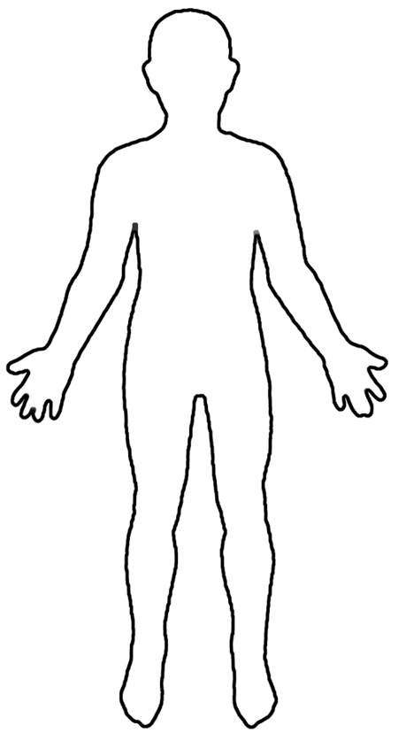
Question: Are any of my body sensations or feelings causing me distress or causing me to change the way I do something in order to function?
- YES: Answer the follow-up questions on the next page and bring this form with you to your next medical appointment.
- NO: Stop here.
Follow-up Questions

Think about the body sensations or feelings that are causing you to change the way you do something and answer the following the questions. It can be very helpful to discuss these questions with someone you trust :

- Describe any changes in the way that you are doing something in order to function.

- Explain any of your body sensations or feelings that are causing you distress.

- Is the feeling constant or does it come and go?

- Does anything make the feeling better or worse? Explain.

- How long has this feeling been happening?

- When did you first notice these feelings?

- Have the feelings changed over time? Explain.

- Has your ability to function changed over time? Explain.

- Are you needing more help to function due to these body sensations?

Remember: bring this Body Check Form with you to your medical appointment along with your Appointment Prep Form

