Before Appointment Reminder Card

Purpose:

The purpose of this card is to provide a visual reminder of an upcoming healthcare appointment and to help you remember to take the steps needed to be prepared. Usually preparing for an appointment in a strategic way can help to reduce some of the anxiety you may experience over healthcare appointments.

Please note: this card provides a great starting point, but, if desired, please adapt it to meet your specific needs.

Directions:

- Print the card. You will notice that the card has 2 sides:

Side 1: The front side provides a short list of reminders to do approximately 3 days before the appointment. If you scheduled an appointment and it is closer than 3 days, that is okay. You can still use the front side to help you prepare 1-2 days before the appointment.

Side 2: The back side provides a short list of what to do on the day of the appointment. Preparing for the appointment by gathering the items you need ahead of time and then taking some time to regulate right before leaving can be very helpful in managing anxiety.

- Hang the front side on your visual schedule 1-3 days before the appointment. Read through the short list and complete the items listed to help you prepare.

- On the day of the appointment display the front side of the card on your visual schedule. Read through the short list and compete the items listed to help you prepare.

Helpful Hints:
- When completing this form, especially the first few times, it may be helpful to do it with the help of a trusted person.
- Keep the completed version of you Appointment Prep Form in your Healthcare Folder so that all of your paperwork for the appointment in one spot.

Before Appointment
Front
Three days before my appointment answer the following questions and act if needed

- If it is the first time I’m seeing this provider, have I completed the About Me Form and put it in My Healthcare Notebook?

- Have I completed the Appointment Prep Form and put it in My Healthcare Notebook?

- Do I need to make a 1-2 minute video describing my symptoms to help with communication during my appointment?

- Do I need someone to accompany me to my appointment? If so, who and have I asked them?
What I need to do the day of my appointment

Place my sensory bag and my healthcare notebook by the door.

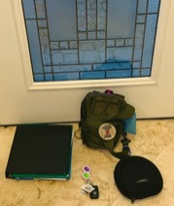

Sensory regulate for 15 minutes by

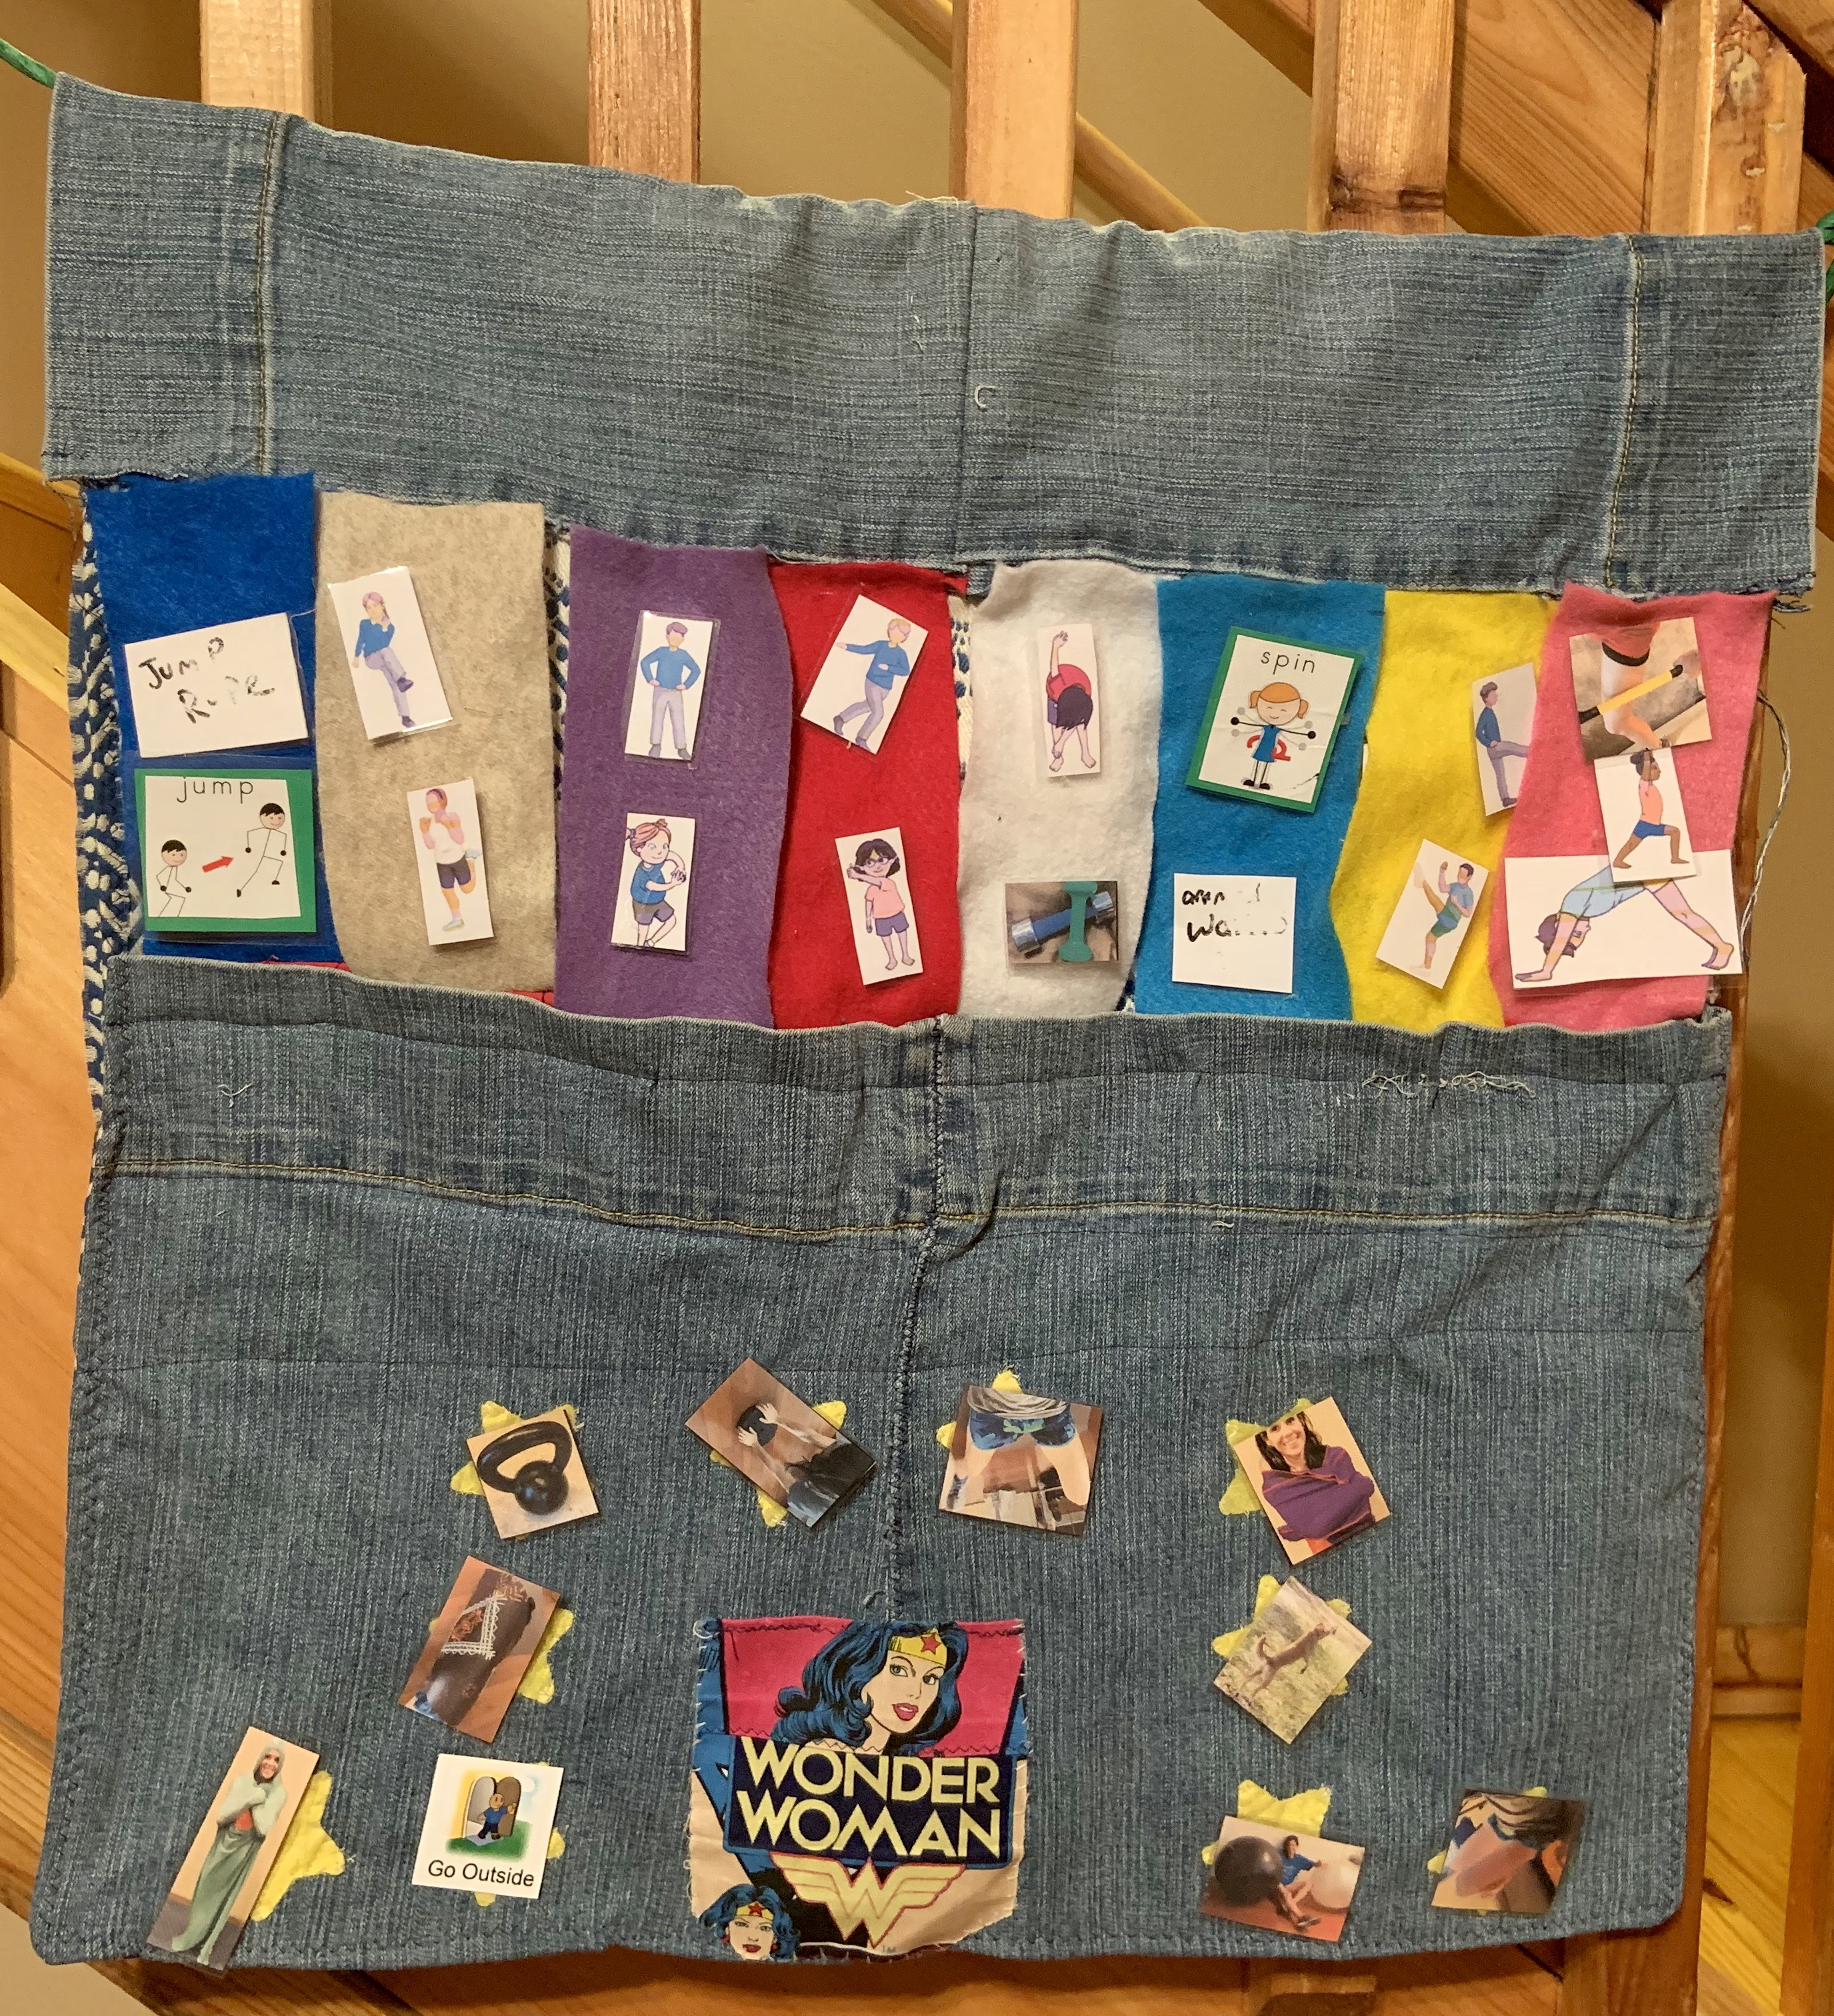
Taking a walk OR by doing sensory routine
Before Appointment
Back

